SmartPlant® Layout White Paper

Automated Pipe Routing Theory



Contents

Overview 3

SmartPlant Layout Objectives 3

Pipe Routing Concepts 3

Pipe Routing Data 3

Engineering Facts 4

Routing / Layout Data 4

Costs 6

SmartPlant Layout implementation 8

SP Layout architecture 8

SmartPlant Layout role 8

SmartPlant Layout Workspace 9

SmartPlant Layout rules 9

Rules implemented in software 10

Data driven rules 10

Model driven rules 12

Equipment Rules 13

# Overview

This white paper describes some of the terminology and conventions used in the pipe routing technology that is used by SmartPlant® Layout.

The SmartPlant Layout pipe routing calculations are performed by the I-Route automated pipe routing software component developed by Alias Ltd in the UK, prior to the company being acquired by Intergraph Corporation in 2006. Although the user is not aware of this, much of the behavior of SmartPlant Layout is based on the requirements of I-Route.

# SmartPlant Layout Objectives

The objectives of SmartPlant Layout are to

* propose clash free routes that follow a set of practical rules, obey the pipe route specs and minimize the cost of installed pipe work
* enablerapid evaluation of alternative plant layout schemes by providing accurate quantities of piping materials

# Pipe Routing Concepts

Conceptually, SmartPlant Layout’s job is to compute the optimum routing for a set of lines (Routes) defined by To/From data (as in a typical line list) plus some physical data (nominal size) and a space containing an arbitrary set of objects. These objects influence the possible route, obstructing, attracting or repelling the pipe.

A Routewill start and end at one of the following

|  |  |
| --- | --- |
| Type | Description |
| Point | *a 3D point and a direction* |
| Nozzle | *Connects to an Equipment Nozzle in the model* |
| Pipe End | *Connects to another PipeRun at its end* |
| Pipe Branch | *Connects to another PipeRun at a branch* |
| Zone | *The surface of a connection zone (essentially a free floating nozzle)* |
| Equipment | *The surface of the range box for the equipment* |

# Pipe Routing Data

The SmartPlant Layout routing data divide into three categories

* Engineering Facts
* Routing Data
* Costs

## Engineering Facts

It must be possible to fabricate any pipe designed by SmartPlant Layout; therefore route generation must obey several engineering facts which are largely determined by the physical dimension of the pipe and fittings.

|  |  |
| --- | --- |
| Parameter | Description |
| Standout | *this is the distance between an end connection and the start of a bend or tee. This is generic it represents the space required for a flange, screwed connection or piece of pipe, it could also be zero.* |
| Bend Length | *this is the distance from centreline of inlet connection to plane of outlet connection. This is generic, can represent ‘Elbow Length’* |
| Tee Leg Length | *this is the distance from the branch tee leg connection to the centreline of the inline tee leg. This is generic, can represent butt weld or flanged fittings and can represent ‘Nozzle Length’ for a welded nozzle branch connection.* |
| Tee Inline Length | *this is the distance from the inlet ( or outlet) in-line connection to the centreline of the branch tee leg ( twice this distance is actual in-line length between inlet and outlet connections). This is generic, can represent butt weld or flanged fittings ,and can represent part (half) of ‘Branch Spacing’ for a welded nozzle branch connection* |
| Joint Diameter | *this is the diameter of pipe flange based on nominal size and rating* |
| Insulation Thickness | *this is the thickness of insulation or tracing used to generate ‘Pipe Envelope’ and ‘Joint Envelope’* |

## Routing / Layout Data

Rather than being concerned with whether the pipe can be fabricated these rules are about good routing practice.

|  |  |
| --- | --- |
| Parameter | Description |
| Pipe Air Gap | *this is the radial distance between external surface of pipe and any other surface* |
| Joint Air Gap | *This is the radial distance between outside edge of flange and any other surface* |
| Branch Gap | *this is a possible add-in factor for combining ‘Pipe Envelope’ and/or ‘Joint Envelope’ to generate ‘Branch Spacing’. May be zero.* |

The router needs to obey the minimum spacing constraints embodied in Pipe Clearance (centreline to object surface), Pipe Spacing ( centreline to centreline) , Branch Spacing ( centreline to centreline). Passing combinations of Pipe Spacing and Branch Spacing values for different combinations of routing specs to the router is avoided by employing the concept of Pipe Envelope and Joint Envelope. Among the information are values of pipe air-gap, Joint air-gap and branch gap which can be user specified and for which reasonably universal default values apply.

The router has to sum the pipe radius value and any insulation/tracing thickness value with the pipe air gap value to produce the Pipe Envelope

|  |  |
| --- | --- |
| Parameter | Description |
| Pipe Envelope | *this is the envelope radius of the pipe, including insulation/tracing and air-gap, can be based on nominal size rather than true size (OD)* |

The router has to sum the flange radius value and any insulation/tracing thickness value with the Joint air gap value to produce the Joint Envelope

|  |  |
| --- | --- |
| Parameter | Description |
| Joint Envelope | *this is the envelope radius of flanged pipe, based on true flange size including insulation/tracing and air-gap, so dependent on rating as well as nominal size* |

Acceptable Pipe Spacing and Pipe Clearance for normal pipe and flanged pipe are then created as a consequence of the router simply using the Pipe Envelope or Joint envelope. For example:-

For unflanged pipe routing through space,

Pipe Clearance = Pipe Envelope

For flanged pipe routing through space

Pipe Clearance = Joint Envelope

For pipe to pipe spacing (eg on a pipe rack):-

Unflanged to Unflanged,

Pipe Spacing = Pipe Envelope 1 + Pipe Envelope 2

Unflanged to Flanged,

Pipe Spacing = Pipe Envelope + Joint Envelope

Flanged to Flanged,

Pipe Spacing = Joint Envelope 1 + Joint Envelope 2

For flanged pipe branch connections

Branch Spacing = Joint Envelope 1 + Joint Envelope 2 + Branch Gap

Or = Tee Inline Length 1 + Tee Inline Length 2 whichever is larger

For flanged pipe branch adjacent to unflanged pipe branch connections

Branch Spacing = Joint Envelope + Pipe Envelope + Branch Gap

For unflanged pipe branch adjacent to unflanged pipe branch connections

Branch Spacing = Pipe Envelope 1 + Pipe Envelope 2 + Branch Gap

Or = Tee Inline Length 1 + Tee Inline Length 2 whichever is larger

## Costs

SmartPlant Layout uses costs to make choices between alternate routes. The costs need only be relative (for example, give 1” Carbon Steel a cost of $1/foot and all other costs are set relative to that. Two fundamental cost parameters (which are included in the reference data) are

|  |  |
| --- | --- |
| Parameter | Description |
| Linear Cost | *cost of pipe straight per unit length, default value =1* |
| Bend Cost | *this is the equivalent ‘cost weighted’ length of a bend which is to be added to the pipe straight length to produce an overall length or ‘cost’ of routed pipe* |

Routes are influenced by “zones” which define space where it is ***more*** or ***less*** desirable to run pipes

|  |  |
| --- | --- |
| Zone | Description |
| Obstruction | *A volume through which the pipe cannot go under any circumstances* |
| Rack | *A user defined space with a strong attraction and specific layout rules.* |
| PipeZone | *A space associated with a piece of equipment or structure to which pipes are attracted and some layout rules apply.* |
| AvoidanceZone | *A space to be avoided if possible but can be entered if essential, eg a vessel bund.* |
| ConnectionZone | *A volume that allows an PipeRun to connect anywhere on its surface. It represents a generic equipment item, which is not detailed.* |
| Free Space | *Any space with none of the above designations.* |

The use (or otherwise) of zones is influenced by the:-

**Zone Cost Factor** *this multiplies the pipe run length to produce a higher or lower cost of routed pipe*.

The default of 1 is for pipe routed in **Free Space** and is considered to include the support costs.

|  |  |
| --- | --- |
| Zone | Typical Cost Factor |
| Rack | *it will be between a minimum value and 1* |
| PipeZone | *it will be higher than a PipeRack but still less than 1* |
| AvoidanceZone | *it will be higher than 1* |
| Free Space | *1.0* |

*All these factors must be user definable.*

Consider the following example:-



In engineering terms PIPE1 connects Pumps P1 and P2 to Vessels V1 and V2, but the SmartPlant Layout To/From definition would be

|  |  |  |  |
| --- | --- | --- | --- |
| PipeRun | From | To | Nominal Size |
| PipeRun1 | Nozzle1 [P1/N2] | End1 | 4” |
| PipeRun2 | End1 | Nozzle3 [V1/N1] | 3” |
| PipeRun3 | Nozzle2 [P2/N2] | Branch1 | 4” |
| PipeRun4 | Branch2 | Point1 | 1” |
| PipeRun5 | Branch3 | Nozzle4 [V2/N1] | 2” |

# SmartPlant Layout implementation

## SP Layout architecture

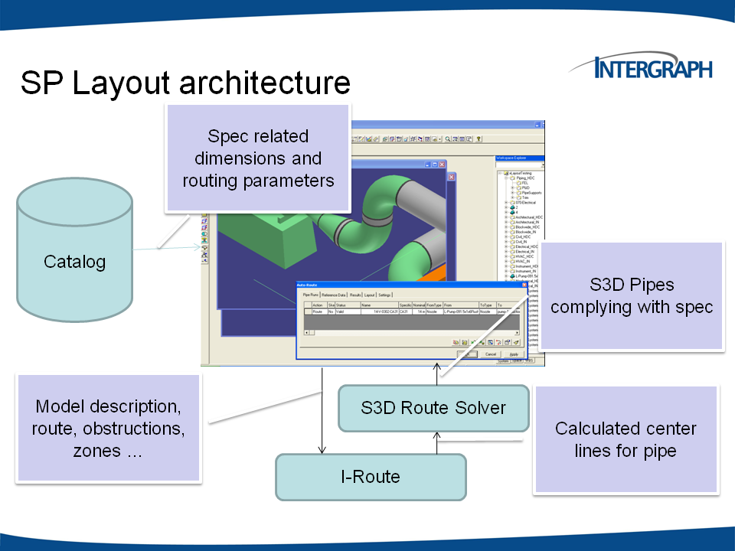

SmartPlant Layout routes PipeRuns – connected sets of pipe with turn, connection and size change pipe components. Each PipeRun has associated Reference Data – it is linked to a Pipe Spec that controls many default choices – such as the type of turn and branch component to use in particular situations. In SmartPlant Layout, the Reference Data is extended to include certain spec driven auto routing related rules and data. Both the standard and the extended reference data for the PipeRun strongly influence the results of the auto routing calculations.

## SmartPlant Layout role

* sets up the problem geometry (nozzles, racks, zones and obstructions)
* describes the route to be calculated by creating PipeRuns and defining their start and end points
* sets up the routing parameters and rules
* displays the result as routed pipe and as quantities and “costs”
  + the routed pipe conforms to the in built design rules according to the chosen material class – for example default turn, size change and connection components are selected from the material class rules.

## SmartPlant Layout Workspace

SmartPlant Layout uses the current Workspace to determine the scope of the routing problem. That is, items visible to the user, because of the current filter defining the content of the Workspace, are the only items used in the auto routing problem.

Items that are Hidden in the Workspace are also excluded.

The set of objects is further limited by the end points of all PipeRuns being routed. When a Preview or Route command is issued, SPL gathers geometry from a volume defined by the set of To/From points and the current workspace

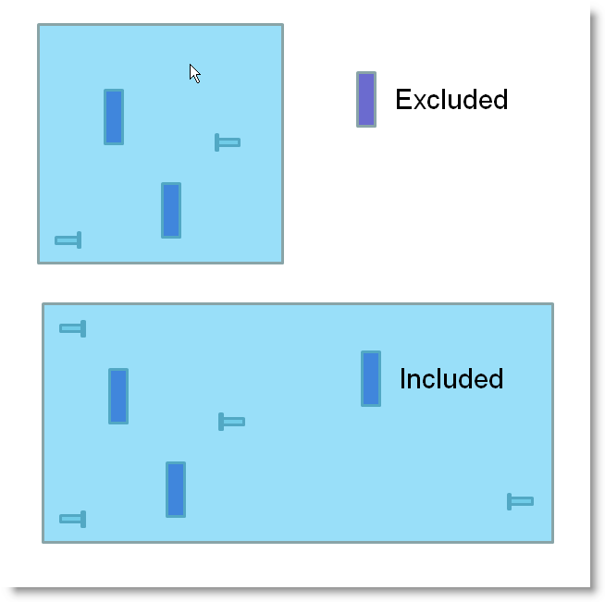

## SmartPlant Layout rules

The SmartPlant Layout automated pipe routing software was designed to be quick and easy to set up, with a minimum of data. One of the frequently voiced objections to competitive systems was the time it took to define the problem to be solved. SmartPlant Layout rules build on SmartPlant Layout capability, but in addition take account of the multiple “rules” built into the SmartPlant 3D software that is the core platform for SmartPlant Layout.

There are a number of different factors that control the behavior of the auto router.

### Rules implemented in software

By definition these cannot be changed by the user, as they need a change to logic. This type of rule is felt to be so fundamental that allowing the user to modify it would be of little value. Typically, the rule is based on good engineering practice.

Examples of this type of rule are

* Pipe is always routed orthogonally and turns are 90 degrees.
  + An exceptions is permitted when a nozzle is oriented off a primary direction, when the pipe will initially be developed in the direction of the nozzle before turning to a primary direction
  + Another exception is when the AllowSkew parameter is set True and the offset between ends of the PipeRun is less than two bend lengths
* Pipe will always join a Rack from above or below
* When avoiding a clash between PipeRuns with the same linear cost, the smaller bore pipe is moved first
* When avoiding a clash between PipeRuns of the same size, the one with the lower linear cost is moved first
* The pipe route is selected only on economic grounds – no consideration of support or stress relief requirements is made.
* At a nozzle (including floating nozzles implied by connection zones), pipe is developed by a fixed distance (the Standout) before a turn can be used, allowing for the placement of flanges and size change components.
* There is precedence between routing objects when they overlap
  + A rack can pass through an obstruction
  + An obstruction takes precedence over anything completely inside itself

### Data driven rules

Certain behavior of the auto routing software is strongly influenced by data in the material class or properties that can be set by the user.

The following five parameters can be set in the piping material class data and are pipe size dependent. If not present they will be set to default values and can be overridden by the user on the PipeRun.

#### Linear Cost Factor

This influences the sorting of pipes on a rack, where line sizes are equivalent (the PipeRun with the higher Linear Cost Factor will not be moved from the optimum route to avoid a clash).

#### Bend Cost Factor

Each turn (bend or elbow) is treated by the routing software as an additional length of pipe – this can strongly influence the choice of route. For example, if turns are “expensive” the auto router may reject the use of a Rack, because it involves additional turns.

The Linear Cost Factor is a cost / unit length of the pipe and the Bend Cost Factor reflects the **additional** cost of each elbow – the router treats each elbow as an additional length of pipe, hence the higher the Bend Cost Factor, the more the router avoids placing turns.

For example, if the Linear Cost Factor = 2 cost/in and the Bend Cost Factor = 4 cost/in, each elbow will be equivalent to an additional 4 / 2 * 2 * Elbow Leg Length = 4 * Elbow Leg Length of straight pipe.

#### Branch Gap

This determines the separation between adjacent branches.

#### Joint Air Gap

This influences the separation between adjacent pipe on a rack, if the line is flanged

#### Pipe Air Gap

This influences the separation between adjacent pipe on a rack, if the line is welded. This represents a simplification of normal rules. The separation of two pipes on a rack is the sum of their individual air gaps.

The following important parameters are computed by SmartPlant Layout based on information in the catalog.

#### Bend Length

The default turn component is used to determine the size dependent bend length. An allowance for weld gap and minimum pipe length is added to avoid issues with adjacent turns when the SmartPlant pipe is constructed.

#### Standout (Nozzle, Equipment, Connection Zone)

The default standout is computed based on allowing for the default connection component (typically a flange) plus any necessary size change components and an allowance for weld gap and minimum pipe length. The standout selected can be overridden by the user.

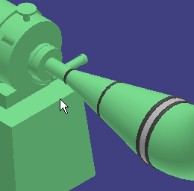

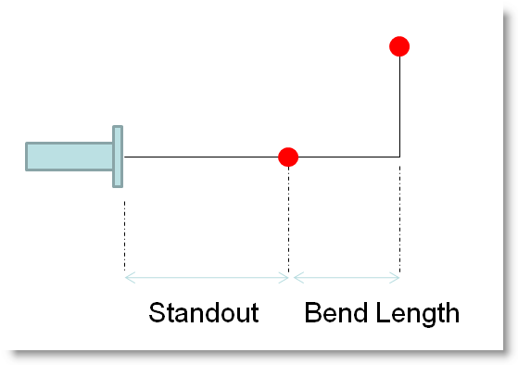

### Model driven rules

The behavior of the auto routing engine is most strongly influenced by the placement of routing objects – such as racks and zones – in the model itself. The important routing objects in SmartPlant Layout are members of the Space Management object hierarchy.

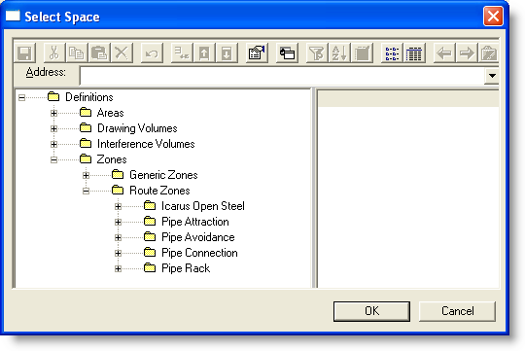

* Obstructions
  + a volume that the route must avoid
  + all SmartPlant objects (for example equipment and structure) are broken down to Obstructions
* Avoidance Zone (Pipe Avoidance)
  + A volume that penalizes (adds to cost of) a pipe that enters it
  + Avoidance Zones have cost factors > 1 and this can be modified
  + An Avoidance Zone is NOT an obstruction
  + The length of pipe within the avoidance zone is multiplied by the cost to determine the penalty for being within the zone
* Rack Zone (Pipe Rack)
  + An “attraction” zone for pipe
  + Cost factor (<1.0) multiplied by pipe length gives the benefit for using the rack
  + Use of a rack is not guaranteed, it is based purely on cost

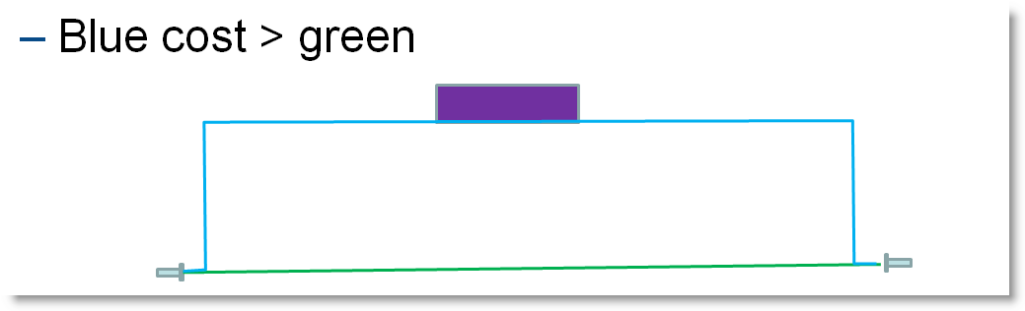

* + Pipe can enter above or below at any point
  + Pipe only runs in one direction, typically the major axis
  + Pipe can be selected by fluid type
  + Pipe spacing according to envelope, as described above and user specified layout parameter (e.g. “Large Bore at Edge”)
* Attraction Zone (Pipe Attraction)
  + Another “attraction” zone for pipe with Cost Factor < 1.0
  + Layout less constrained than Rack
  + Pipes are not “sorted”
  + Can be used as a “way point” for a single pipe
  + Can be used as a “slab” or “surface” on which pipes run

It is possible to constrain a route so that a pipe run is forced to pass through a particular set of zones – the “Vias” list.

An important feature of SmartPlant Layout is that it operates within the SmartPlant environment and this means that all the functions of the Piping task for manually routing lines are available to the Layout engineer.

Where detail has to be correct, it is often more productive to route pipes manually, particularly in congested areas and then auto route to connection points.

### Equipment Rules

The SmartPlant Layout equipment library can be a powerful way of expressing an organizations own rules for piping layout. SmartPlant Layout includes a basic set of equipment symbols, including the Pipe Rack.

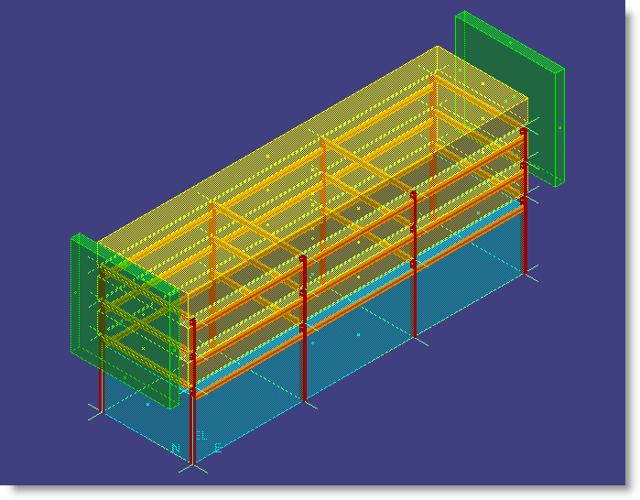

This is a good example of a relatively complex assembly – it comes with multiple routing zones and associated structure. It can be a very productive tool during early design.

It is open for any organization to implement their own equipment assemblies and if there are particular rules for piping up those equipment items, to include local piping in the equipment assembly. The auto router can be used to connect up the “open ends” rather than attempting to force it to conform to the standard layout in routing to the equipment nozzles.

This is a flexible way to include proprietary equipment and / or behavior in early routing studies with a high degree of realism. It requires the programming of rules into the equipment symbol.

**Headquarters**

**Intergraph Corporation**

170 Graphics Drive

Madison, AL 35758

For more information about Intergraph, visit our Web site at www.intergraph.com.

Intergraph, the Intergraph logo, SmartPlant, are registered trademarks of Intergraph Corporation. Microsoft and Windows are registered trademarks of Microsoft Corporation. Other brands and product names are trademarks of their respective owners. Intergraph believes that the information in this publication is accurate as of its publication date. Such information is subject to change without notice. Intergraph is not responsible for inadvertent errors. ©2010 Intergraph Corporation. All Rights Reserved.

